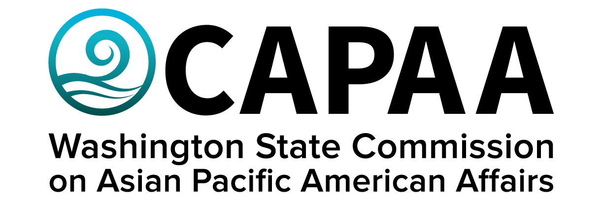

Public Board Meeting Agenda
Saturday, September 10:00 a.m. – 2:00 p.m. via Zoom
Wapato Filipino Community Hall
211 W 2nd St
City of Wapato, Yakima County, WA 98951

AGENDA
Time | Business Item | Speaker
10:00 AM | Call to Order | Chair Nguyen
10:01 | Roll Call | Chair Nguyen
10:02 | Welcome (10 min) | Representative Alex Ybarra
10:12 | Approval of Agenda  - Action to approve | Chair Nguyen
10:13 | Approval of Minutes  - Action to approve | Chair Nguyen
10:15 | Commissioner Community Updates (5 min each) | Roundtable
11:00 | Staff Report | Exec Dir Hasegawa
11:30 | Lunch | Catered by Fil-Am Yak Valley
11:55 | Public Comment
12:05 | Presentation: History of Interracial Solidarity in Yakima Valley | Lon Inaba & Stan Viernes
12:35 | Elections  - Executive Committee  - Chair  - 1st VC  - 2nd VC  - Standing Committee Chairs & Assignments  - Civil Rights & Immigration  - Economic Development  - Education  - Health & Human Services  - Ad-Hoc Committee Chairs & Assignments  - Environmental Justice  - Legislative | Chair Nguyen
1:15 | Strategic Plan Overview & Update | Project Manager Yodkerepauprai
1:30 | CID Issues | Matt Chan
1:50 | Good of the Order | Chair Nguyen
2:00 PM | Adjourn | Chair Nguyen

