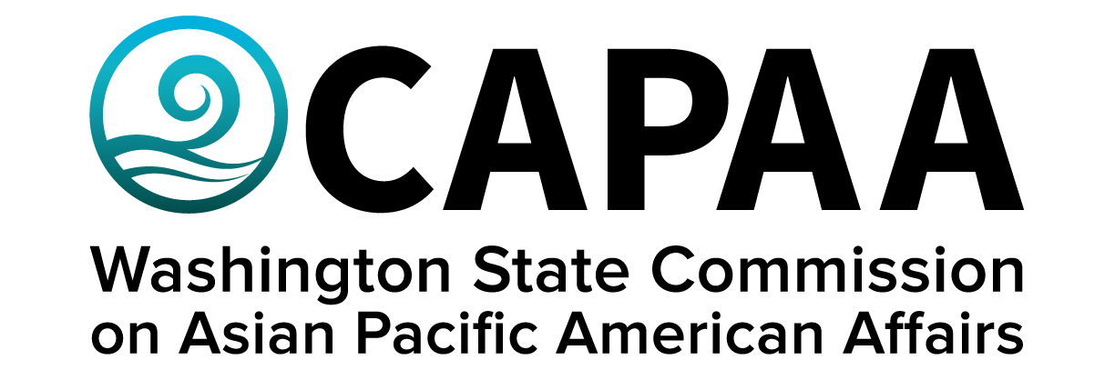

**Staff Report**

**January 28, 2022**

Prepared by:

Executive Director Toshiko Hasegawa

Project Coordinator Brenda O’Brien

Project Manager K’gnausa Yodkerepauprai

January Public Board Meeting: **Pierce County**

Improving the well-being of Asian Pacific Americans by examining issues, advancing advocacy, and ensuring access to government.

**Staff Report**

January 28, 2023

Staff report to the Commission covering activities, progress, and updates from November 19, 2022 to January 27, 2023.

1. **STAFF AND COMMISSIONER ACTIVITY**

**Commissioner Activity:**

Commissioners submitted activity reports for the time period of November 5, 2022 to January 13, 2023. Total events reported = 89; Activity Report response rate = 100% (12/12 respondents). Outstanding reports for this period: *none.* Details of Commissioner Activity can be found in Appendix I.

OSPI sought CAPAA’s support in identifying a community member to serve upon OSPI’s School-Based Behavioral Health and Suicide Prevention (SBBHSP) Subcommittee of the Healthcare Authority’s [Children and Youth Behavioral Health Work Group](https://gcc02.safelinks.protection.outlook.com/?url=https%3A%2F%2Fwww.hca.wa.gov%2Fabout-hca%2Fprograms-and-initiatives%2Fbehavioral-health-and-recovery%2Fchildren-and-youth-behavioral-health-work-group-cybhwg&data=05%7C01%7CToshiko.Hasegawa%40capaa.wa.gov%7Cd03414d3b7e1442977df08daeeaeb3b6%7C11d0e217264e400a8ba057dcc127d72d%7C0%7C0%7C638084731348546638%7CUnknown%7CTWFpbGZsb3d8eyJWIjoiMC4wLjAwMDAiLCJQIjoiV2luMzIiLCJBTiI6Ik1haWwiLCJXVCI6Mn0%3D%7C3000%7C%7C%7C&sdata=BBacnFOnL9r007o8xRJw0JJX8k8ATo3LHmLqAJ%2Fal6c%3D&reserved=0) (CYBHWG). The subcommittee advises the full work group on creating and maintaining an integrated system of care through a tiered support framework for kindergarten through twelfth grade school systems defined by OSPI and behavioral health care. This representative would not formally represent CAPAA upon this committee.

1. **FINANCE**

**Financial Status Report:** The January 2023 Financial Status Report shows that CAPAA is in good financial condition. In a worst case scenario, if CAPAA does not receive funding for any of its asks, the agency will overspend its allocation $14,000. Overspend is attributed to the professional production of CAPAA’s reports, grants, Commissioner compensation for lived experience, and staff salary increases. There is also a rumor of revenue sweeps, but it doesn’t seem CAPAA will be impacted because last year it spent its entire allocation and the current spend projections.

**Decision Packages:** Governor Inslee’s 2023 Supplemental and 2023-25 Biennial Budgets were released. CAPAA is shown in section 122: [https://ofm.wa.gov/sites/default/files/public/budget/statebudget/2023-25biennial/2023-25BiennialOperZ-0211.2.pdf](https://gcc02.safelinks.protection.outlook.com/?url=https%3A%2F%2Fofm.wa.gov%2Fsites%2Fdefault%2Ffiles%2Fpublic%2Fbudget%2Fstatebudget%2F2023-25biennial%2F2023-25BiennialOperZ-0211.2.pdf&data=05%7C01%7CToshiko.Hasegawa%40capaa.wa.gov%7C943760b381df44f4addb08dade358b13%7C11d0e217264e400a8ba057dcc127d72d%7C0%7C0%7C638066618936760669%7CUnknown%7CTWFpbGZsb3d8eyJWIjoiMC4wLjAwMDAiLCJQIjoiV2luMzIiLCJBTiI6Ik1haWwiLCJXVCI6Mn0%3D%7C3000%7C%7C%7C&sdata=LLpXmfCUsTvTWjGFTijznhe65MpRIBv1YFoQBgJkKdE%3D&reserved=0).

* They partially funded the maintenance-level request, reducing the total amount by $31,000 for the biennium.
* They included more than anticipated in our policy-level request, which is $62,000 more than anticipated for the biennium.
* They are funding interpreter/translator services and Lived Experience Stipends, as requested.

For employees, below is a summary of what was included:

* A general wage Increase of 4% in July 2023 and 3% in July 2024.
* A retention lump sum payment for staff continuously employed from July 1, 2022, through July 1, 2023.
* A $1,000 COVID-19 booster vaccination incentive.

A recap of CAPAA’s Decision Package requests are as follows:

1. Civic Engagement – [see CAPAA’s full Civic Engagement Decision Package Request here.](C://Users/toshiko.hasegawa@capaa.wa.gov/Downloads/DP-PL-CE-Civic%20Engagement%20(1).pdf)

The Commission requests $108,086.77, or $110,000 rounded, for the 2023-25 biennium, to cover the basic costs associated with civic engagement, including travel for Commissioners and staff, translation and interpretation services, equipment needed to support hybrid operations, and the publication of cornerstone informational reports.

1. Lived Experience – [see CAPAA’s full Lived Experience Decision Package Request here.](C://Users/toshiko.hasegawa@capaa.wa.gov/Downloads/DP-PL-S1-Lived%20Experience%20Stipends.pdf)

Summary: CAPAA requests $85,200, or $86,000 rounded, to cover the cost of appointee compensation based on “lived experience” for official meetings taking place in the 2023-25 biennium.

CAPAA will return to the legislature with a 2023-2024 supplemental budget request to cover the cost of a necessary website rebuild and webpage services provided by WA Tech.

**Sponsorships:** The Executive Committee approved sponsorship requests for the following:

* $500 – UTOPIA WA – Miss Island Goddess Beauty Pageant 2023 – March 11, 2023, 6 PM @ King County. Full details of the request can be found in Appendix II.
* $500 – Vietnamese Community of Clark County Lunar New Year Celebration – January 28, 2023 @ Eleanor Roosevelt Elementary School. Full details of request can be found in Appendix III.
* $500 – Spokane United We Stand Lunar New Year Celebration – January 28, 2023 @ Spokane Convention Center. Full details of request can be found in Appendix IV.

The following sponsorship request was rejected, because it did not meet CAPAA’s minimum qualifications:

* $500 – K-Pop Night – Supreme Entertainment – January 27th @ “el corozon”. Full details of request can be found in Appendix VI.
* $500 – Race Against Hate – Stage Auto Center Full details of request can be found in Appendix V.

The sponsorship request form has been amended to include the question, “How does this event advance CAPAA’s mission, ‘to improve the lives on ANHPI’s in Washington State?”

This fiscal year has already blown past our budgeted $6,000 in grants/sponsorships to CBO’s with current spend at $7,000, with 5 months left to go in the fiscal year.

1. **STRATEGIC PLAN**

CAPAA entered into a $6,000 contract with KD Hall Communications to formally produce its Strategic Plan. The final Strategic Plan was publicly released on Tuesday, January 17th to Governor Inslee, agency leads, deputy directors and members of the public at-large (including media) in January. [It can be accessed online here.](https://capaa.wa.gov/wp-content/uploads/2023/01/CAPAA-Strategic-Plan-2023-2026.pdf)

1. **2022 Demography Report**

CAPAA released its updated Community Demography Report on Friday, January 6 with an internal email blast to all statewide elected officials, large and small agency heads, deputy directors and Commissioners, as well as an external press release to media and newsletter blast to our full listserv.

The report was produced by Kaya Strategic, who conducted demographical analysis of AA & NHPI community racial and ethnic groups using Census 2020 data, which was disaggregated to the fullest extent possible using ACS 2020 data. The report can be accessed online at capaa.wa.gov.

1. **APIC Legislative Days**

APIC Legislative Days will take place virtually February 7 – 8 with a public kick-off event taking place February 7th @ 9:00 am. A meeting with Governor Inslee and advocates will take place February 8, 9:00 – 9:30 am via Zoom. A meeting with Speaker Jinkins will take place February 8, 2023 3:45 – 4:00 pm via Zoom.

1. **COMMUNICATIONS**

**Webpage:** CAPAA’s hosting site Hostgator experienced failure that caused CAPAA’s website to go down for one full business day. The source of the problem has not been identified, but it follows a meeting we had with WA Tech where the agency was advised of its lack of security and vulnerability. WA Tech was able to recover the full webpage. The following week, CAPAA entered into an interagency agreement with WA Tech to support CAPAA’s webpage. This includes a use of a new hosting site “Pantheon” called Pantheon. For now, we are keeping WordPress, but will eventually need to rebuild the website under a new server called “Drupal”, a project that will occur sometime Fall 2023 and cost about $15,000. (WA Tech and CAPAA will work together on submitting a DP to cover the cost of the rebuild). The cost for WA Tech service under Wordpress is $200/mo, and the cost once we migrate to Drupal will be $300/mo.

**Newsletter:** CAPAA’s newsletter is sent to an e-mail listserv of 2,859 contacts (+43 from November Staff Report). The newsletter was sent a total of 3 times to the full listserv.

**Facebook:** 2,838 Follows up from2,834 in November (+4). Highest performing post was a APCC New Year Celebration Flyer which had a reach of 990. Posts average reach is 336 each.

**Outside Events:** Governor’s Equity Summit, POC Legislative Summit, State of the State, APIC Trainings, MLK Opportunity Fair at Garfield HS, Meeting with Senator Maria Cantwell regarding recent mass shootings

**Governor’s Proclamations:** Governor Inslee issued two proclamations: One celebrating Korean American Day and another for Lunar New Year.

**Instagram:** 110 Followers (+44). Highest performing post was Korean American Day Proclamation with 77 accounts reached and 23 likes.

**Webpage:** Webpage Updates, CAPAA bill tracker, Commissioner bio updates

**Earned Media:**  North American Post: Demography Report,

South Seattle Emerald: interview with ED Hasegawa about Demography Report, International Examiner article by Joshua Lee

1. **UPCOMING EVENTS**

APIC Legislative Kick-Off (virtual)

Tuesday, February 7, 9:00 – 10:00

APIC Meeting with Governor Inslee (virtual)

Wednesday, February 8, 9:00 – 9:30

APIC Meeting with Speaker Jinkins (virtual)

Wednesday, February 8, 3:45 – 4:00

APCC Lunar New Year Celebration

Saturday, February 25, 11:00 am

Tacoma Dome Exhibition Hall

March Public Board Meeting

Saturday, March 11, 10:00 – 2:00 PM

Washington State Capital – Legislative Building – Columbia Room

416 Sid Snyder Ave SW Olympia, WA

June Public Board Meeting

Saturday, June 10, 10:00 – 2:00

Spokane Convention Center

334 W Spokane Falls Blvd Spokane, WA

September Public Board Meeting

Saturday, September 9, 10:00 – 2:00

Everett Community College

2000 Tower Street Everett, WA

November Public Board Meeting

Saturday, November 18, 10:00 – 2:00

Together Center, 16305 NE 87th St. Redmond, WA 98052

**APPENDIX I: Commissioner Activity Reports**



**APPENDIX II: Sponsorship Request – Miss Island Goddess Beauty Pageant 2023**

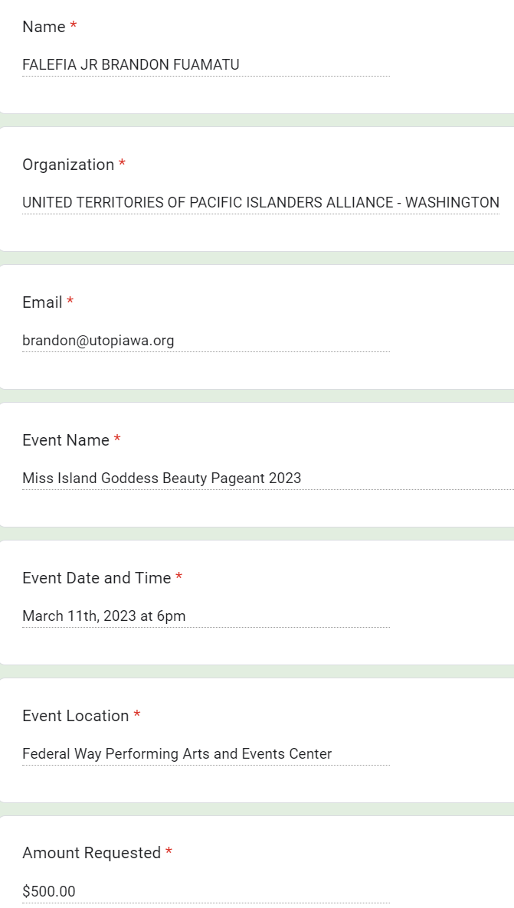

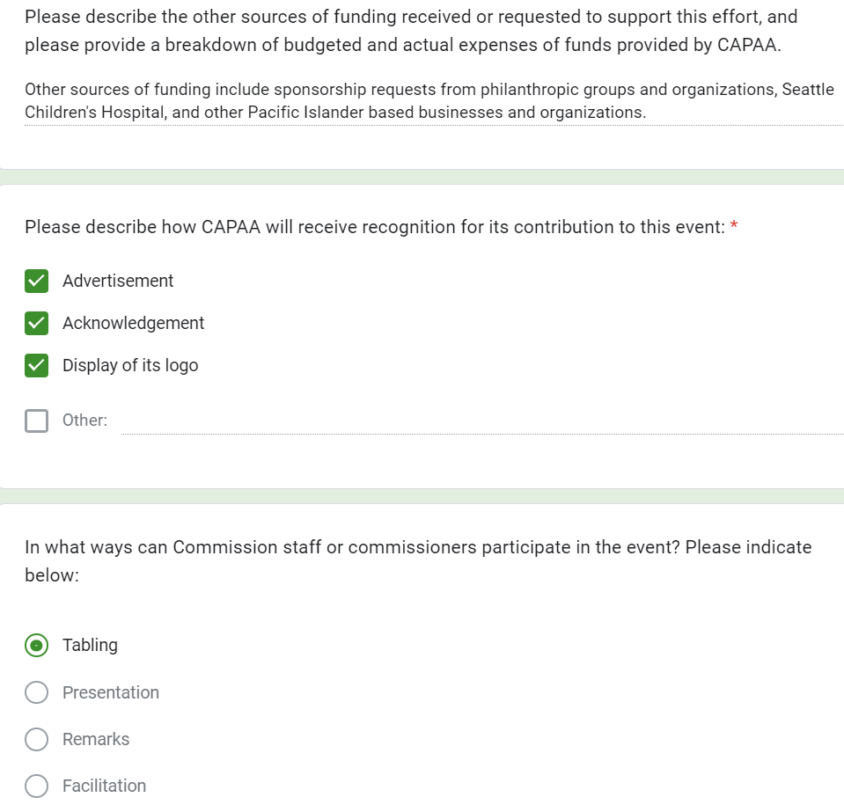

**APPENDIX III: Sponsorship Request – Vietnamese Community of Clark County Lunar New Year Celebration 2023**

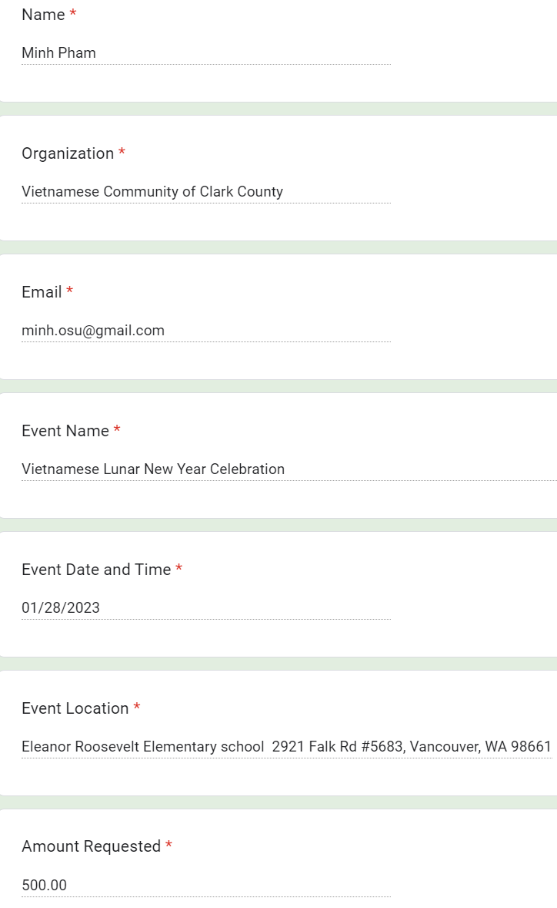

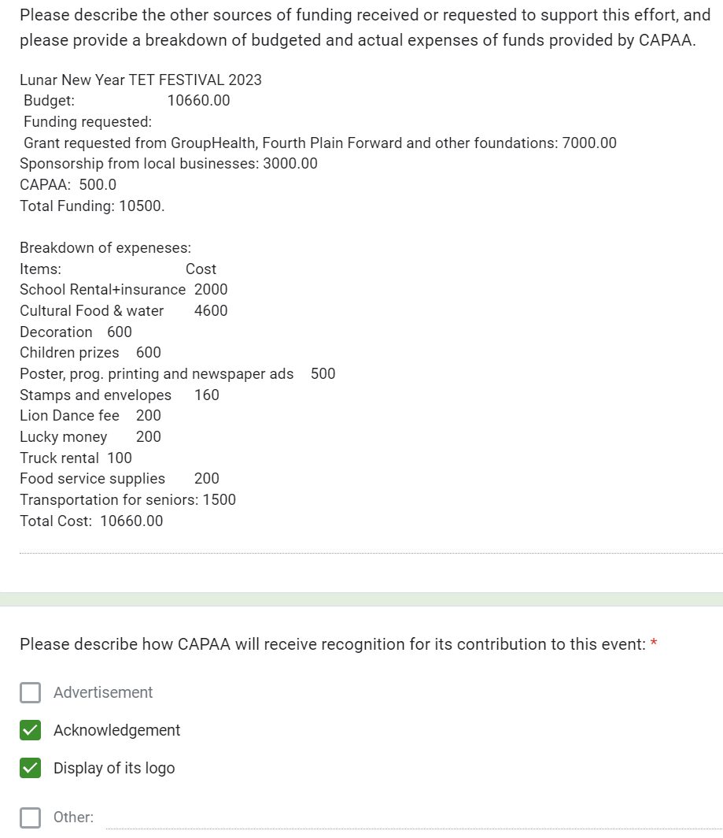

**APPENDIX IV: Sponsorship Request – Spokane United We Stand Lunar New Year Celebration 2023**

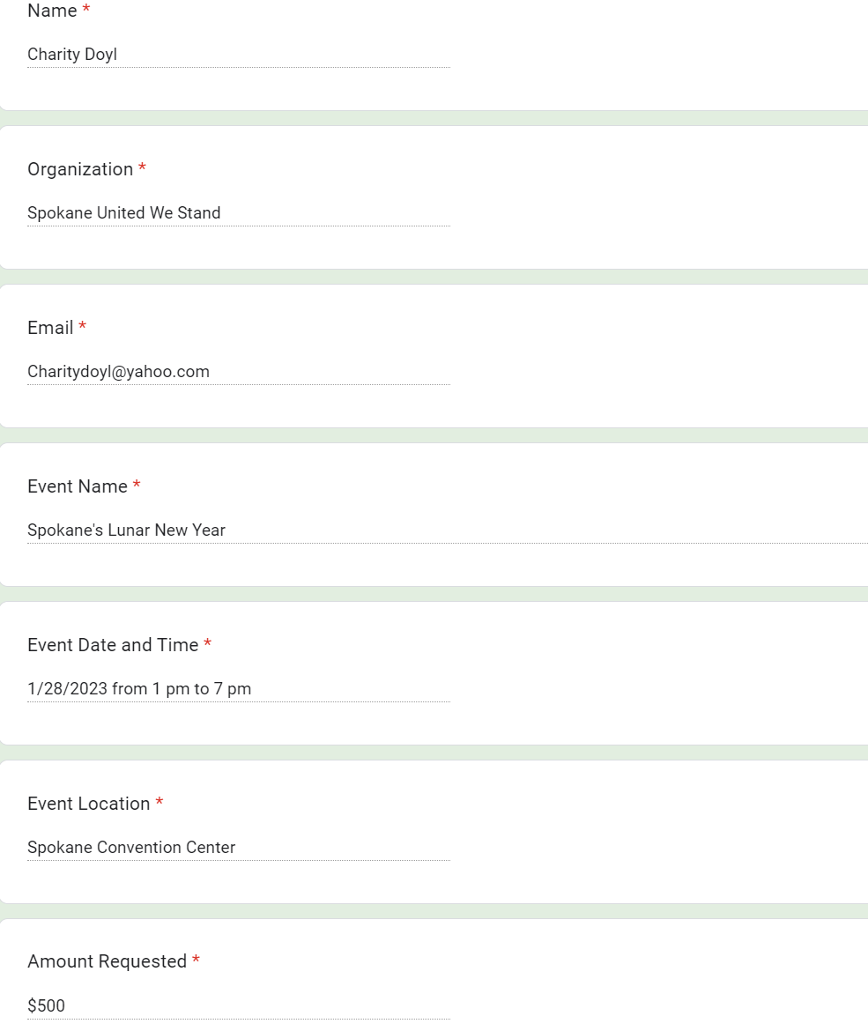

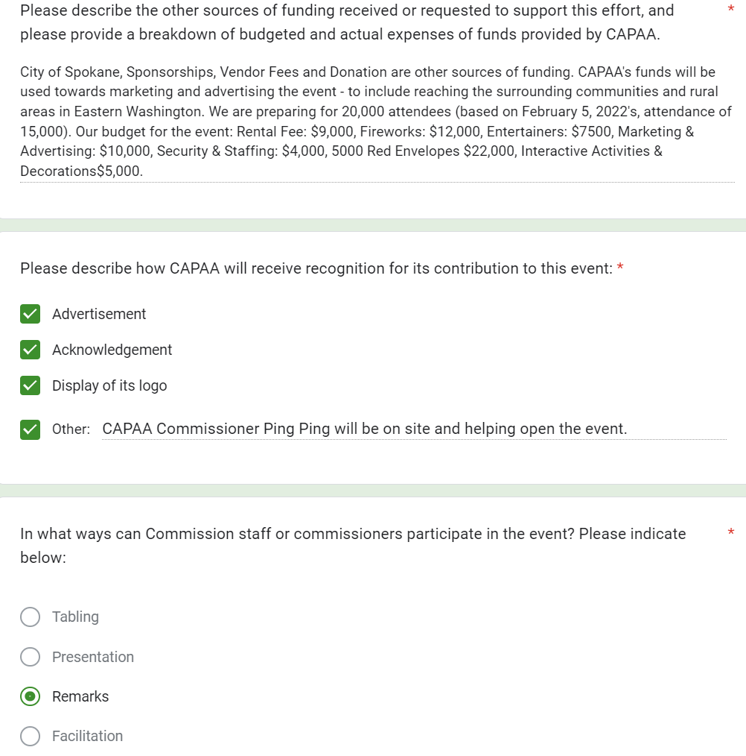

**APPENDIX V: Sponsorship Request – Race Against Hate**

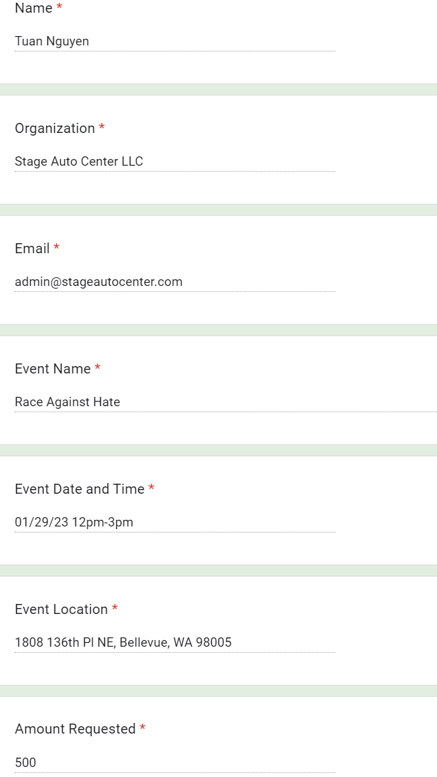

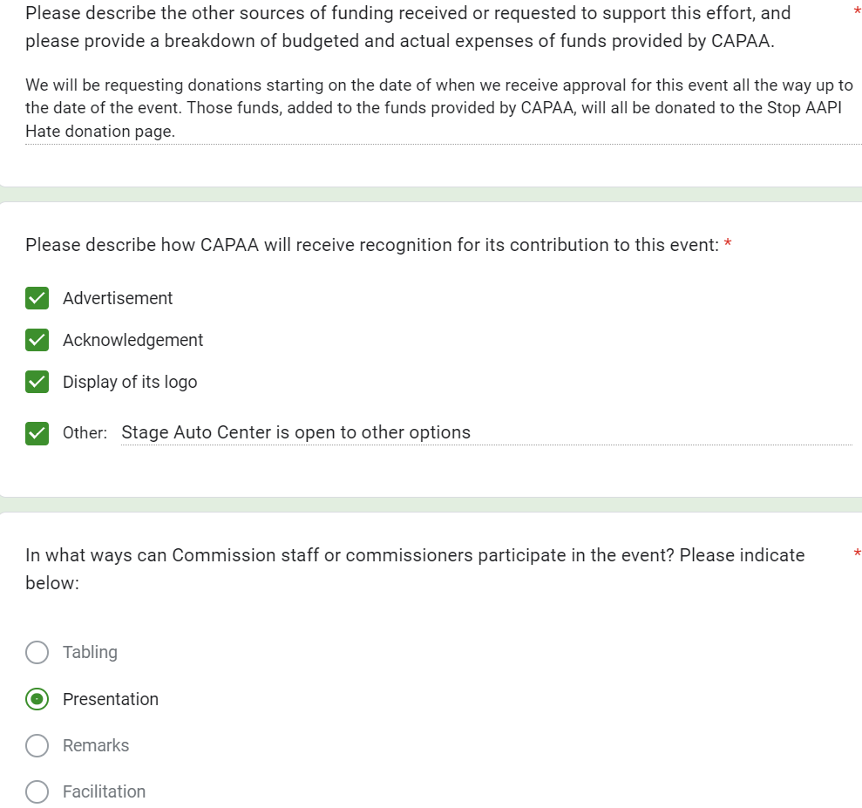

**APPENDIX VI: Sponsorship Request – K-pop Night – Supreme Entertainment**

