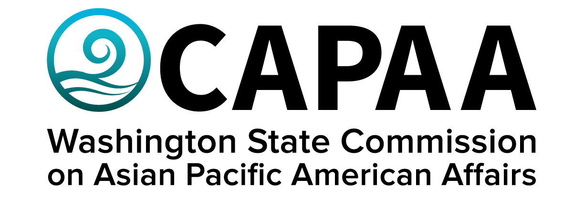

Public Board Meeting Agenda
Saturday, June 25, 2022; 10:00 a.m. – 2:00 p.m.
The Civic Building: 322 N Commercial St. Bellingham, WA 98225

AGENDA
Time | Business Item | Speaker
10:00 AM | Call to Order | Chair Nam Nguyen
10:01 | Roll Call | Chair Nam Nguyen
10:02 | Welcome (10 min) | Cmmr. Satpal Sidhu  (Whatcom Co. Exec)
10:12 | Approval of Agenda  - Action to approve | Chair Nam Nguyen
10:13 | Approval of Minutes  - Action to approve | Chair Nam Nguyen
10:15 | Sponsorship Requests  - Fil-Am Yakima Valley 70th Ann. Celebration ($500)  - Action to approve  - Representative to attend (Yakima)  - Japan Festival @ Mukai Farm & Garden ($500)  - Action to approve  - Representative to attend (Vashon Island) | Chair Nam Nguyen
10:30 | Commissioner Community Updates (5 min each) | Roundtable
11:20 | Lunch/Break | Catered by Tandoori Bites
11:40 | Labor & Industries LEP Community Relations | Carmen Rivera  Community Relations Specialist  Department of Labor & Industries
11:55 | Public Comment
12:25 | Staff Report | Director Toshiko Hasegawa
1:10 | Video Presentation: The Arc of Healing & Reconciliation | Cmmr. Satpal Sidhu
1:30 | Adjourn | Chair Nam Nguyen
1:30 PM | The Arc of Healing & Reconciliation Monument Tour  Commemorating discrimination against East Indian, Chinese, and Japanese immigrants in the PNW | Guided by Cmmr. Satpal Sidhu

