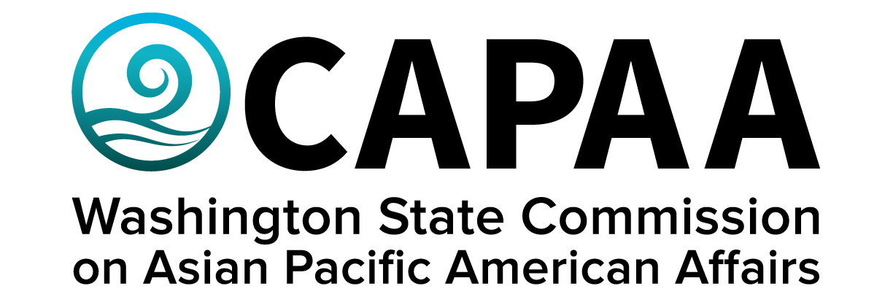

**Staff Report**

**June 25, 2022**

Prepared by:

Executive Director Toshiko Hasegawa

Project Coordinator Brenda O’Brien

Project Manager K’gnausa Yodkerepauprai

June Public Board Meeting: **Whatcom County**

Improving the well-being of Asian Pacific Americans by examining issues, advancing advocacy, and ensuring access to government.

**Staff Report**

June 25, 2022

Staff report to the Commission covering activities, progress, and updates from March 19, 2022 to June 24, 2022.

1. **STAFF AND COMMISSION ACTIVITY**

**Commissioner Activity:**

Commissioners submitted activity reports for the time period of March 5, 2022 to June 10, 2022. Total events reported = 108; Activity Report response rate = 83% (11/12 respondents). Outstanding reports for this period: 1. (*Missing: Cmmr. Sidhu).* Details of Commissioner Activity can be found in Appendix I.

**Appointments:**

K’gnausa Yodkerepauprai was appointed to represent CAPAA upon the Washington State Semiquincentennial Celebration Committee.

Matt Chan was appointed to represent CAPAA upon the Washington State Creative Economy Strategic Plan Workgroup, effective through December, 2023.

Four Commissioners were recommended for re-appointment: Chair Nam Nguyen (Thurston County), 1st Vice Chair Lydia Faitalia (King County), and 2nd Vice Chair Carrie Huie-Pascua (Yakima County), and Civil Rights Committee Chair Kendall Kosai (Snohomish County).

Caryn Park was re-appointed to represent CAPAA upon OSPI’s Social Emotional Learning Workgroup. She current serves as Co-Chair of the workgroup.

**Sponsorships:** The Executive Committee approved sponsorship requests for UTOPIA Washington and Washington State ANHPI Employee Resource Group organizations who applied via the online portal, including:

* Utopia Washington, Lu’au: Le Nofo, $500
* Washington State ANHPI Employee Resource Group, BRG Kickoff Event, $500

One sponsorship requests was denied because they did not meet the minimum requirements necessary for approval.

* United Samoan Organization of Washington, Crickett and Youth Summer Programs, $500

1. **FINANCE**

The March 2022 Financial Status Reports show that CAPAA is in good financial condition. It is projected to spend its entire appropriation. Other significant policy-level changes provided for in the supplemental budget include:

Pursuant to 2SSB 5793, the Office of Equity issued interim best practices for compensating community members for their expertise, including for Commissioners. Effective immediately, CAPAA will compensate Commissioners for their participation in public board meetings. If you would like to ***opt out*** of receiving compensation for participating in board meetings, please let us know. Otherwise, we will assume you will accept the stipend and process it for each Commissioner after the board meeting.

1. **STRATEGIC PLAN**

The Commission has begun the process form the 2023-2025 Strategic Plan. Developing the strategic plan is a year-long process that lays the vision, goals and objectives for the next three years, led by Committee Chairs and requiring input and participation from all 12 Commissioners.

* Civil Rights & Immigration
* Economic Development
* Education
* Health & Human Services

Three committees met to provide high-level input to staff on the contents of the strategic plan. The Civil Rights & Immigration Committee will convene on July 22nd. Staff hopes to have a first draft of a strategic plan available for committee review in August, 2022.

1. **EDUCATIONAL DISPARITY STUDY**

Representative Santos sent a letter to Governor Inslee that this budget request be vetoed. CAPAA sent a letter in support of this request. We expect her to re-submit a request for funding for a study inspecting the educational disparity gap again next year.

1. **ASIAN, NATIVE HAWAIIAN & PACIFIC ISLANDER HERITAGE MONTH**

APAHM festivities kicked-off in-person at the Seattle Center, where a CAPAA booth was attended by staff, Vice Chair Huie-Pascua, and Commissioner Sisavatdy. A proclamation was provided by Governor Inslee and read on stage by Dir. Hasegawa. APAHM was attended by hundreds of members of the public and included cultural performances and a humbow eating contest. CAPAA also ran a social media campaign in partnership with the Women’s Commission, and re-launched Conversations with CAPAA on Facebook Live.

1. **COMMUNICATIONS**

**Newsletter:** CAPAA’s newsletter is sent to an e-mail listserv of 2,724 contacts (+107 from March Staff Report). The newsletter was sent a total of 5 times to the full listserv.

**Facebook:** 2,776 Follows up from2,707 (+69). Highest performing was a Lau New Year Flyer provided by Cmmr. Sisavatdy which got 15,361 impressions. Posts average 300 impressions each.

**Conversations** 1) ANHPI’s in Environmental Justice ft. Kat Holmes, Washington Conservation

**with CAPAA:** Voters; Sui-Lan Ho’okano, Enumclaw School District, & Sameth Mel, Partners in Change. The total number of impressions for this Conversation = 1,133, It was shared 22 times and got 8 reactions.

2) Access to Health Services ft. WA State Secretary Dr. Umair Shah; Michael Byun, ACRS; Michael Itti, CISC. The total number of impressions for this Conversation = 249 impressions, with 23 reactions and 5 shares.

**Webpage:** Updates to Welcome Page, Board Meetings Tab, API Directory re-instated, newsletter blog updates

**Social Media:** ANHPI Heritage Month Acknowledgements, ANHPI HM posts, Women’s Commission Collaboration, events and opportunities.

1. **UPCOMING EVENTS**

**September Public Board Meeting – Yakima County (in-person)**

Saturday, September 17, 2022

10:00 AM – 2:00 PM

**November Public Board Meeting – King County (in-person)**

Saturday, November 19. 2022

10:00 AM – 2:00 PM

**APPENDIX I: Commissioner Activity Reports**



