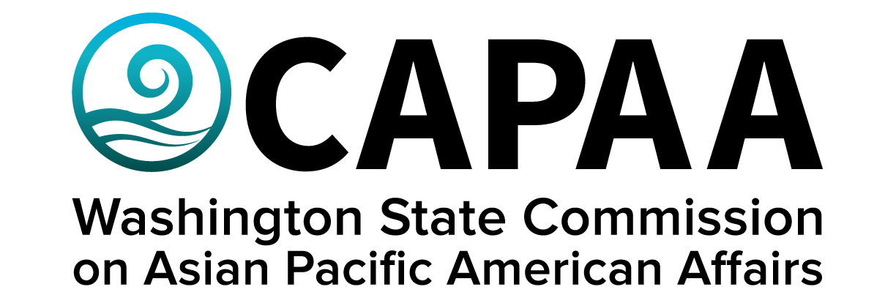

**Staff Report**

**November 19, 2022**

Prepared by:

Executive Director Toshiko Hasegawa

Project Coordinator Brenda O’Brien

Project Manager K’gnausa Yodkerepauprai

November Public Board Meeting: **King County**

Improving the well-being of Asian Pacific Americans by examining issues, advancing advocacy, and ensuring access to government.

**Staff Report**

November 19, 2022

Staff report to the Commission covering activities, progress, and updates from September 16, 2022 through November 18, 2022.

1. **STAFF AND COMMISSIONER ACTIVITY**

**Commissioner Activity:**

The Commissioner activity report has been updated! We have made the form more simple and quicker to complete, and more relevant to the desired information collected annual by OFM.

Commissioners submitted activity reports for the time period of September 3 to November 11, 2022. Total events reported = 83; Activity Report response rate = 91% (11/12 respondents). Outstanding reports for this period: Commissioner Cho. Details of Commissioner Activity can be found in Appendix I.

1. **FINANCE**

**Financial Status Report:** The November 2022 Financial Status Report shows that CAPAA is in good financial condition. Currently, fiscal year-to-date, the agency has underspent by $8,693. That being said, September costs were higher than expected due to the Commission awarding donations to community based organizations.

**Decision Packages:** CAPAA submitted two decision package requests for consideration by the Governor and legislature in the 2023-25 budget:

1. Civic Engagement – [see CAPAA’s full Civic Engagement Decision Package Request here.](C://Users/toshiko.hasegawa@capaa.wa.gov/Downloads/DP-PL-CE-Civic%20Engagement%20(1).pdf)

Civic engagement is central to the operations of the Commission and integral to its ability to fulfill its mission and funding is necessary for the agency to continue operating at a baseline level. Due to equity impacts from Covid-19 and the rise in anti-Asian hate, demand for agency services continues to grow. The geographic, ethnic and language diversity of the ANHPI community present significant challenges when aiming to conduct culturally appropriate and accessible outreach. Inflation makes maintaining programs challenging and expansion of service impossible. The Commission requests $66,086.77, or $67,000 rounded, per fiscal year, to cover the basic costs associated with civic engagement, including travel for Commissioners and staff, translation and interpretation services, equipment needed to support hybrid operations, and the publication of cornerstone informational reports, The Commission requests $108,086.77, or $110,000 rounded, for the 2023-25 biennium.

1. Lived Experience – [see CAPAA’s full Lived Experience Decision Package Request here.](C://Users/toshiko.hasegawa@capaa.wa.gov/Downloads/DP-PL-S1-Lived%20Experience%20Stipends.pdf)

CAPAA is a small, cabinet-level agency that advises the Governor, legislature, and other state agencies on issues impacting Asian, Native Hawaiian & Pacific Islander Washingtonians. The Washington State legislature passed 2SSB 5793 relatimg to compensating community members who share their expertise with state government> Based upon RCW 43.117, Commissioners who are Asian Pacific Americans likely have lived experience and may receive a stipend. CAPAA requests $85,200, or $86,000 rounded, to cover the cost of appointee compensation based on “lived experience” for official meetings taking place in the 2023-25 biennium.

**Sponsorships:** The Executive Committee approved sponsorship requests for one group that has been sponsored in the past: Korean Women’s Association - $500.The event was organized by Commissioner Chongsun Abbott and attended by Chair Nam Nguyen, Commissioner Cho, and Commission Huie-Pascua. Chair Nguyen gave remarks on behalf of CAPAA and Governor Inslee.

1. **STRATEGIC PLAN**

CAPAA entered into a $7,000 contract with KD Hall Communications to formally produce its Strategic Plan. The project is expected to conclude in January 2023, in time for the 2023 Legislative Session.

1. **2022 Demography Report**

CAPAA has entered into a $25,000 contract with Kaya Strategik to update the 2020 Demography Report, which is based upon 2019 community ACS Data, with data points and figures and assessments based upon Census Decennial 2020 and ACS 2020 data. Kaya will conduct statistical demographical analysis of AA & NHPI communities and convey information as infographics and a final narrative report summarizing key findings.

This report will provide a more accurate 1-year comparison to 2010 Census data. Pairing this information with ACS 2020 survey data (which was just recently released) will allow for the most holistic snap shot of our communities possible. Based upon feedback, we will also aim to better disaggregate NHPI community demographic data by ethnicity and language. This will require an assessment of ACS 2020 microdata, which is labor-intensive.

The project is expected to conclude in December, 2022, in time for ANHPI Lobby Days and legislative session advocacy efforts. The findings will be presented in the January 2022 public board meeting, as well as to agency partners in full cabinet and deputy director meetings. It will also be presented on FB live, which can be shared via our newsletter and social media platforms, and stored in CAPAA’s website.

1. **COMMUNICATIONS**

**Newsletter:** CAPAA’s newsletter is sent to an e-mail listserv of 2,816 contacts (+52 from September Staff Report). The newsletter was sent a total of 3 times to the full listserv.

**Facebook:** 2,834 Follows up from2,798 in September (+36). Highest performing post was a Filipino History Month Proclamation which got 1,783 impressions. Posts average 300 impressions each.

**Outside Events:** ED Hasegawa made video remarks for Filipino American Heritage Month; attended Fil Am Yakima Valley 75th Anniversary event; emceed DENSHO 2022 Gala; met with the Deputy Consul General of Korea; attended inaugural event of Air Tahiti Nui and presented the President of French Polynesia a gift; conducted meetings the 37th LD delegation regarding the Seattle CID; met with Senator Keiser and Representative Orwall regarding community impacts in South King County; facilitated a panel involving Representative Ryu on Equity in the Outdoors at the Washington State Responsible Outdoor Recreation Summit; Traveled to Japan to represent Gov. Jay Inslee at 50th anniversary of sister-city event with Kobe, Japan,

**Instagram:** 66 Followers (First time reporting). Highest performing post was Chair Nguyen speaking at CID Rally. 60 Accounts reached and 10 likes.

**Webpage:** Webpage Updates, CAPAA bill tracker, Commissioner bio updates

**Social Media:** New Linkedin Account Created, Instagram created

1. **CAPAA SEMI-CENTENNIAL**

CAPAA will observe its 50th Anniversary since its establishment in February, 2024. The Commission should decide whether it wants to do an in-person celebration, a virtual tribute, or a campaign. Commissioners and staff should discuss what the goals are in commemorating this milestone (i.e. education, celebration, policy advancement, budget ask to legislature, community fundraiser, etc., togetherness.)

**APPENDIX I: Commissioner Activity Reports**

